Name: _________________ PS ID# ___ COSC 3380

HW 3
(100 points)
(Due date found in the COSC 3380 Detailed Syllabus!)

1. (20 pts)

Examine the Schedule below. There are three transactions T1, T2, and T3.
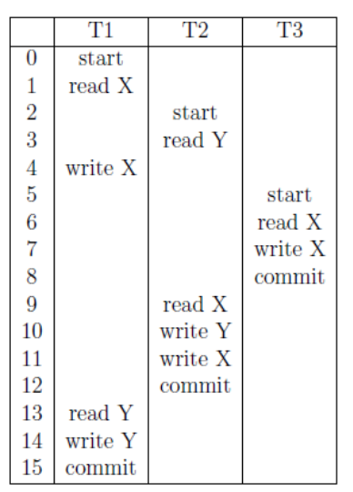
a) Draw the Dependency graph for this Schedule.
b) What is the equivalent serialization order for this Schedule? If no order is possible, state NONE.
c) Assume that transaction T1 did not run at all. Would the Dependency graph be different in this case? Explain.
d) What is the equivalent serialization order for this Schedule? If no order is possible, state NONE.

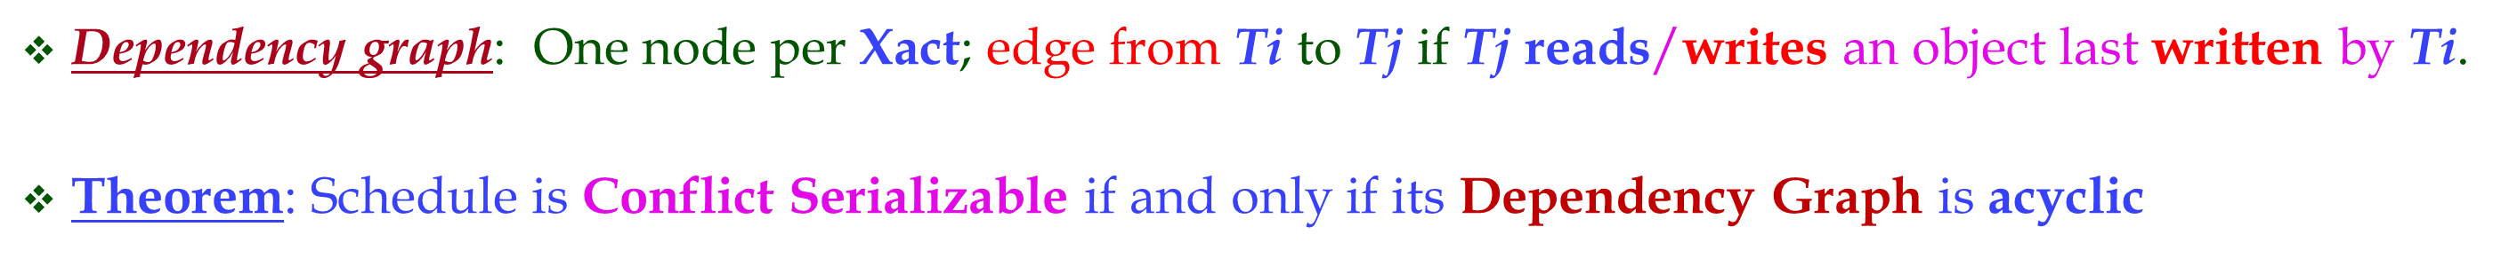
ANSWER:
2. (10 pts)
Draw the Schedule in a vertical timeline manner.
Draw the Serializability Graph for the Schedule S below:

w1(x) r1(x) w3(z) r2(x) r2(y) r4(z) r3(x) w3(y)

If Schedule S is serializable give an equivalent serial Schedule, if not explain why.

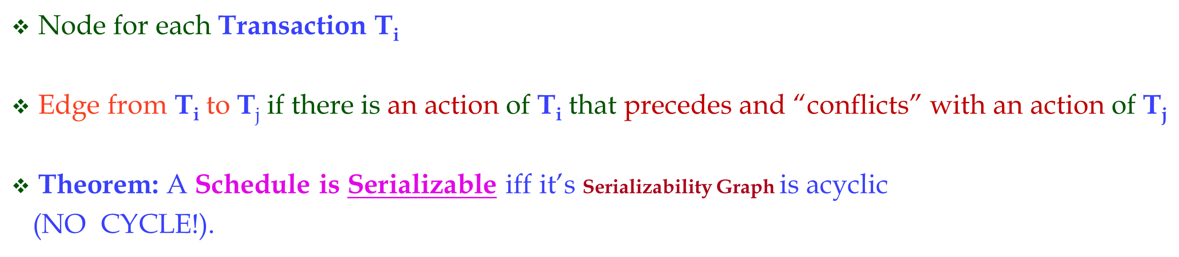

(NOTE: Please create a TABLE format for this Schedule with the columns being the Transactions and the Rows being the Schedule (only one action per Row). Then draw the edges on this TABLE before building the Serializability Graph)

ANSWER:

nodes: T1, T2, T3, T4
directed edges: (T1, T2), T2, T3), (T1, T3), (T1, T4)
S is serializable with equivalent serial schedule T1, T2, T3, T4.
3. (10 pts)
Draw the Schedule in a vertical timeline manner.
Consider the following Schedule obtained from the Schedule S in 2, by adding commit operations:

w1(x) r1(x) w3 (z) c1 r2(x) r2 (y) r4 (z) c4 c2 r3(x) w3 (y) c3

Is this Schedule strict? Explain.

ANSWER:

4. (20 pts)
Draw the Schedule in a horizontal timeline manner with the X and S locks before the W and R.

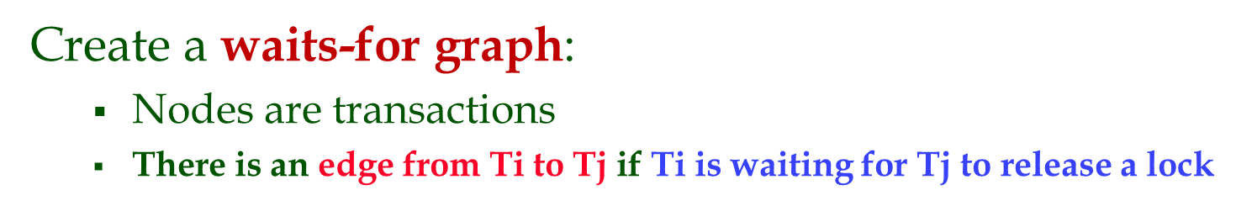
Consider the following sequence of actions, listed in the order they are submitted to the DBMS. Assume Strict 2PL with deadlock detection.
Produce a Wait For Graph (WFG) for the transactions and determine whether deadlock exists.

a. (10 pts)
Sequence S1:
T1:R(X),T2:W(X),T3:W(Y),T1:W(Y),T1:Commit,T2:Commit,T3:Commit
ANSWER:

b. (10 pts)
Sequence S2: T1:R(X),T2:W(Y),T2:W(X),T3:W(Y),T1:W(Y),T1:Commit,T2:Commit,T3:Commit

ANSWER:
5. (10 pts)
Draw the Schedule in a horizontal timeline manner with the X and S locks before the W and R.
Consider the following sequence of actions, listed in the order they are submitted to the DBMS. Assume Strict 2PL with deadlock detection.
Draw a Wait For Graph (WFG) for the transactions and determine whether deadlock exists.

w1(x) r2(x) w2 (y) w2(x) w3 (z) r3 (y) w3 (y) w1 (z) abort1
What happens to T2 and T3 when T1 aborts?
ANSWER:

6. (20 pts)

Consider the execution shown below.
a. Show the log entries till & including LSN 90:
LSN LOG

begin_checkpoint

update: T1 writes P1

T1 commit

update: T2 writes P2

T1 end

T2 abort

Update: T3 writes P3

end_checkpoint

80 T3 commit

90 T3 end

CRASH, RESTART

LSN | Type | prevLSN | nextLSN | Transaction
00
10
20
30
40
50
60
70
80
90

b. Explain why log records could be written between the begin checkpoint and end checkpoint records.

ANSWER:

c. Describe what happens during the Analysis phase and show the DPT and TT.

ANSWER:

d. Show the log entries at the end of the Aries algorithm.

ANSWER:
LSN | Type | prevLSN | nextLSN | Transaction

7. (10 pts)

Consider the following two transactions:

T34: read( A);
read( B);
if A = 0 then B := B + 1;
write( B).

T35: read( B);
read( A);
if B = 0 then A := A + 1;
write( A).

- Add lock and unlock instructions to transactions T34 and T35, so that they observe the two- phase locking protocol.

- Can the execution of these transactions result in a deadlock?

ANSWER:

